**Business and Technical English (Eng201)**

**Fall 2020**

**Assignment ENG201**

**Total Marks: 20**

**Lectures: 23-33**

**Instructions:**

* Upload your assignments in a proper format, i.e. MS word file. Corrupt files will be awarded zero marks.
* The assignments should be zoomed in at 100%.
* Please avoid plagiarism; plagiarized work will be marked zero.
* After the due date, the assignments submitted via email would not be entertained.
* Please avoid submitting copied assignments; otherwise, such a case would be referred to the discipline committee.
* The font color should be preferably black and font size 12 Times New Roman.

**Q1.Visual aids represent information visually. Keeping in mind the twelve types of visual aids i.e. tables, bar graphs, pictographs, line graphs, pie charts, photographs, drawings, diagrams, flow charts, organizational charts, schedule charts and budget statements, identify which visual aid the given image represents. (5 x 2 = 10 marks)**

**1.**

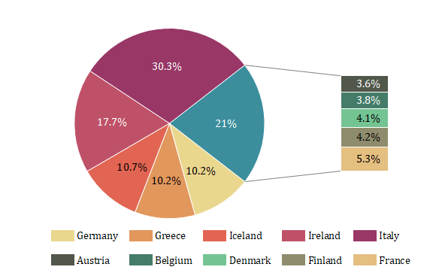

1. **Diagram**
2. **Photograph**
3. **Organizational charts**
4. **Pie Chart**

**2.**

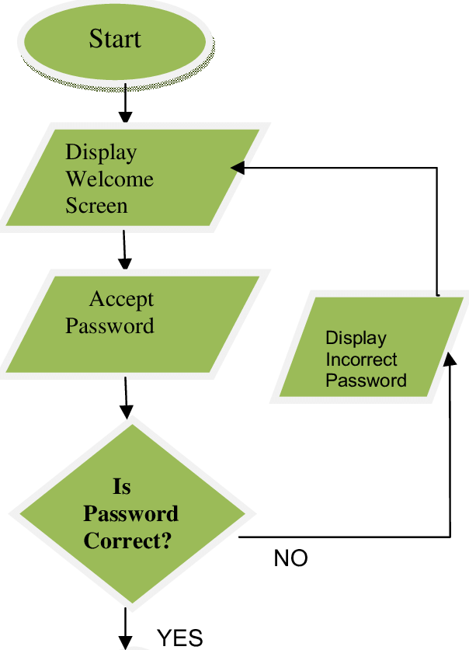

1. **Histogram**
2. **Pie chart**
3. **Flow Chart**
4. **Bar graph**

**3.**

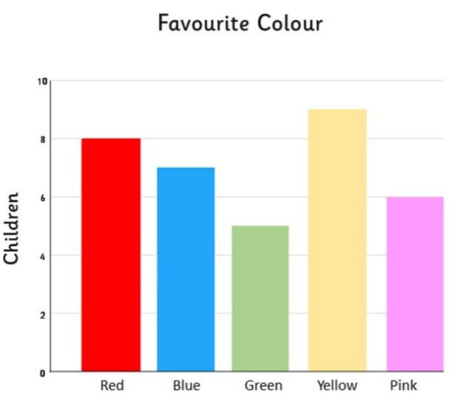

1. **Bar graph**
2. **Pictograph**
3. **Schedule charts**
4. **Drawing**

**4.**

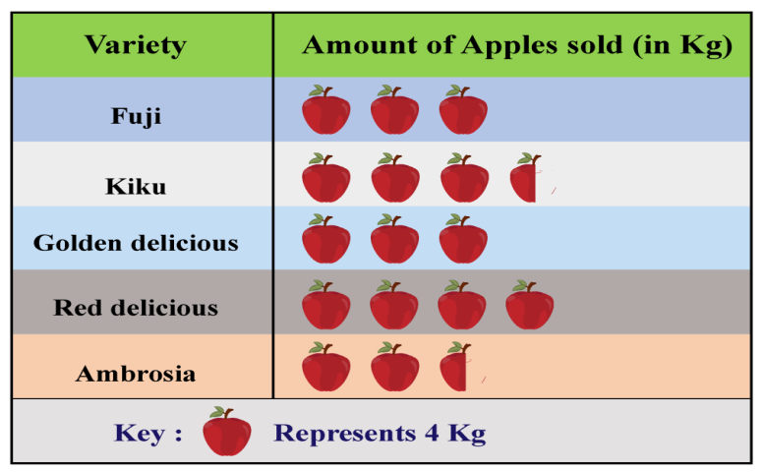

1. **Flow chart**
2. **Pictograph**
3. **Schedule charts**
4. **Drawing**

**5.**



1. **Flow chart**
2. **Organizational charts**
3. **Pie chart**
4. **Diagram**

**Q2. Suppose you are working as sales manager in Olpers. Keeping in mind the following superstructure of proposal, you are asked to write proposal to suggest new methods to improve sales in south division of Lahore. (3+3+4=10 marks)**

* **Introduction**
* **Objectives**
* **Method**